Spring boot / Angular app for dog training center

Author: Andjel Petrovski   
Date: 12/23/2023

Description:  
 App is made for home purposes, it’s only used on home local network and it’s used to mark dogs that will arrive and depart. Owner needs to track how many dogs he has at any moment at any time in the year, and when each dog is arriving and departuring shown in calendar with certain colors.

**SQL Table**   
Columns:

* pas_id = dog_id
* ime_pas = dog_name
* rasa = breed
* starost = age
* ime_vlasnika = owner_name
* prezime_vlasnika = owner_surname
* telefon = phone_number
* datum_dolaska = date_of_arrival
* datum_odlaska = date_of_departure
* mesto = place( place from where dog is coming)

**Java Eclipse (Srping boot) code**

Classes

Pas entity (Dog entity)

Contains:

* All data from SQL database
* Empty constructor
* Constructor using data
* Get, Set and ToString Methods

Pas repository (Dog repository)

* Contains only two methods for find_all_dogs_by_date_of_arrival_order and find_all_dogs_by_their_id  
  Pas controller (Dog controller)  
  A screenshot of a computer program

  Description automatically generated

Contains methods that we will use.

WebConfig

Web configuration was needed to allow authorization for Angular side to do POST, DELETE and PUT.

**All components

* + - * app component (root component)
      * app-routing-module.ts (contains all routes)
      * pas.model.ts (model of data)
      * data-service.ts (service for all methods)
      * lista-pasa component (list of dogs)
      * da-li-briste ( delete dialog component for delete button)
      * dodaj-profil (add-dog component for add dog button)
      * update-profil (update dog information for update button)
      * kalendar-test (calendar component showing all dogs in each date)

data-service.ts  
Methods:

* getAllData() – collecting data of all dogs
* getCounts() – getting count of dogs
* deletePas() – deleting Dog profile
* getAllDataById() – collecting data of one dog based on it’s id
* updatePas() – updating data of certain dog
* addPas() – adds data for dog

app-component.html

This component.html contains toolbar shown in tabs of website. It has Logo routed to list of dogs, “Kalendar” (Calendar) routed to calendar of dogs, “Dodaj Psa” (Add dog) button and “Broj pas” (Number of Dogs) that represents all added dogs.

app-components.ts

NgOninit method loads count of all dogs everytime site is loaded on start.  
openAddProfile() opens matDialog component that contains inputs for adding data for dog.

app-routing-module.ts

Contains routes for Calendar and List of dogs (which is routed on Logo in app component)

Kalendar-test-component.html (calendar component)

Contains

* Shown current year and month
* Form field with inputs for month, year and button for Searching
* Table with shown dates of selected month and selected year

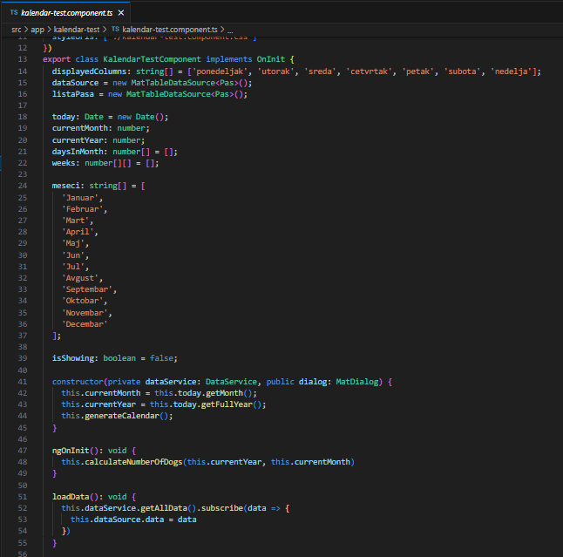Kalenar-test-component.ts (Calendar component)

Contains

* dataSource ( data of all dogs)
* listaPasa (same as dataSource) – used for filtering
* constructor – gering current month, year and generating calendar.
* NgOnInit() – calculates number of dogs per date
* LoadData – load data of all dogs

* generateCalendar – generates calendar, every time it is called, it calculates number of dogs per date in each month.

* writeNumberOfDogsPerDay – returns number of dogs in each day of the month
* writeNameOfDogsPerDay – returns string of name of a dog in each day of the month
* generateValue – gets value of selected month and year
* isArrivalDate – returns boolean value if dog arrived in certain day of month
* isDepartureDate – returns boolean value if dog departure in certain day of month

* getDogNameStyle – if dog has arrived on certain day of month, dog will be marked with green color, and if dog has departured, dog will be marked with red color
* getWeekendCellStyle – marks Saturdays and Sundays with orange color (only for table rows, meaning days in month)
* getWeekenCellStyle2 – marks Saturdays and Sundays with orange color (only for table headers, meaning only “Subota”(Saturday) and “Nedelja”(Sunday) as words)